ZHOU Kevin
Student ID : A0197122H
NUS - IE5101 - Applied Forecasting Methods
Professor : Chen Nan
Project 2 : Forecasting Highway Car Volumes


Table of Contents
2.1 Regression on Time 2
2.1.1 Regression on time 2
2.1.2 Diagnostic check 3
2.1.3 Model interpretation 4
2.2 Exponential Smoothing 4
2.2.1 Naive application of Exponential smoothing 4
2.2.2 Verification of model choice, upsides and downsides 5
2.2.3 Holt-Winters exponential smoothing 6
2.3 Free form forecasting 6
2.3.1 Data cleaning 6
2.3.2 Linear regression 7
2.3.3 Linear regression with ARIMA errors 7
2.3.4 Further Improvements 8

2.1 Regression on Time

2.1.1 Regression on time
In this first part our regression will only consider the variables Time and TrafficVolume for prediction.
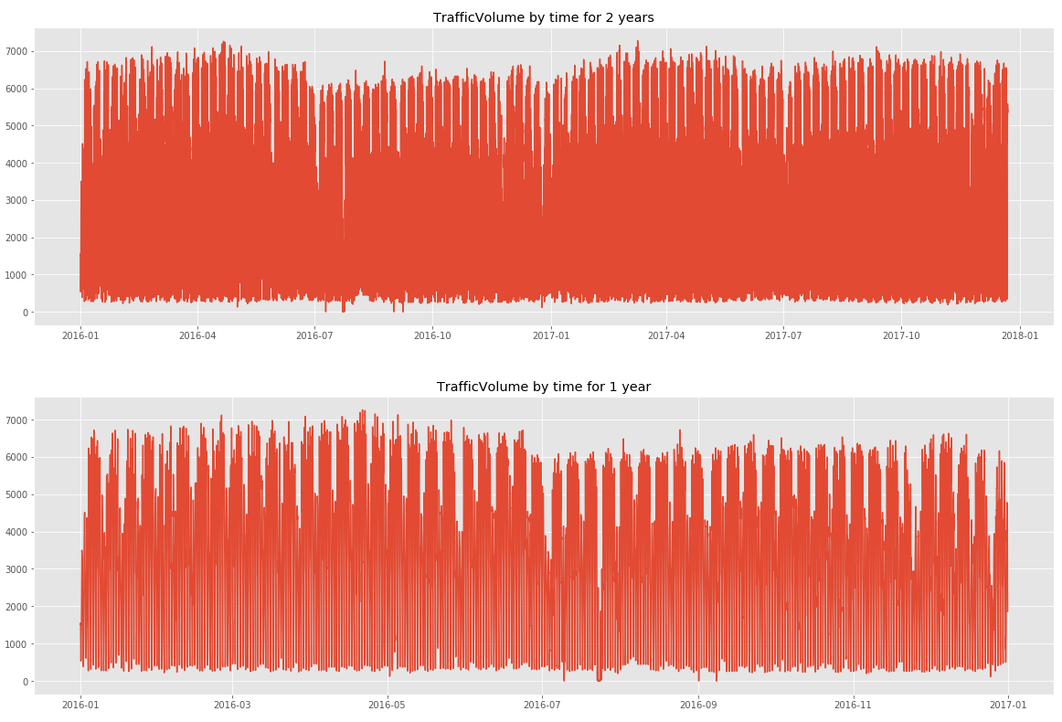
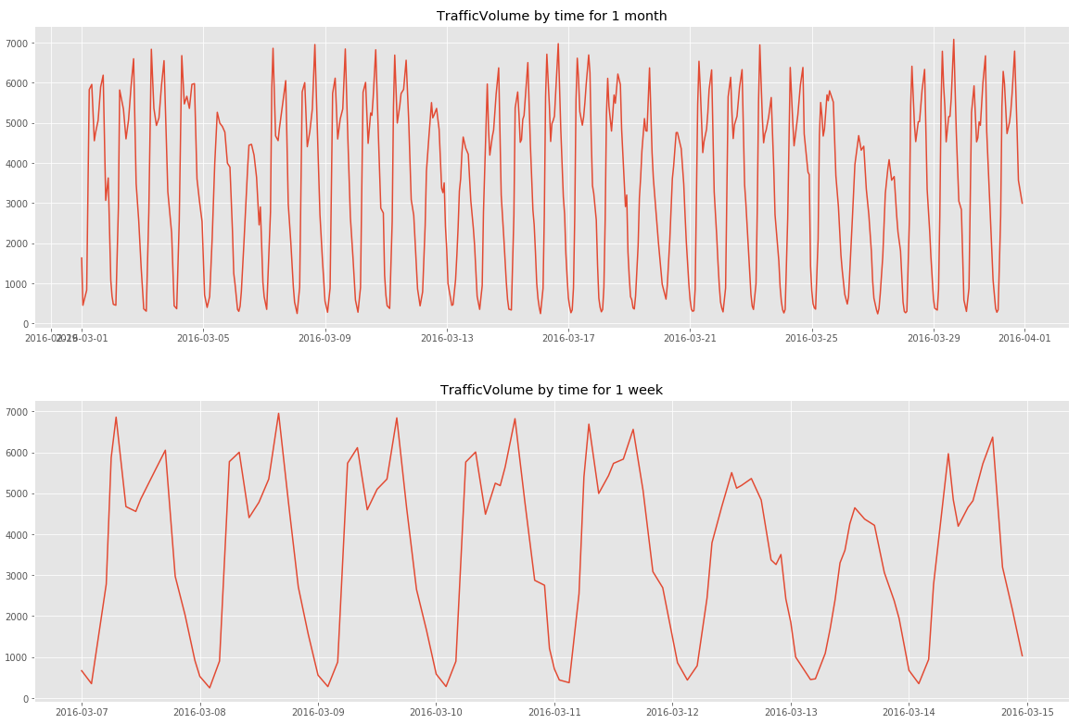
By plotting the Traffic volume, we notice some seasonality linked to the hour (peak around 7 am to 5 pm), to the day of the week (low traffic during the weekend) and and also to the month (plateau around April and minimum around July)

Hence to compute the linear regression, we will introduce dummy variables for the hour of the day, the day of the week and the month of the year and add the year to account for possible trend in time.
To ease the interpretation, we have standardized the year variable: Year= Year -2012

We have opted for time series regression with no trend and constant additive seasonal variation ie y_{t}= TR_{t} + SN_{t} + ε_{t} assuming :
- TR_{t}= β₀ with β₀ constant
- SN_{t}= β_{S1}*x_{S1,t}+ β_{S2}*x_{S2,t}+ … +β_{SN}*x_{SN,t}
with x_{Si} the dummy variables related to the seasonal variation
More precisely x_{Si,t}= 1 if time period t is Si (season i) , 0 otherwise
This has yielded satisfactory results (below). All variables taken are extremely relevant (p-values close to 0) except C(monthofyear)[T.12].

A full model regression with the list of possible features below have resulted in a slightly better R²-adjusted and smaller AIC. A stepwise forward selection regression to automatically select the best variables yielded similar results : better R²-adjusted and smaller AIC.
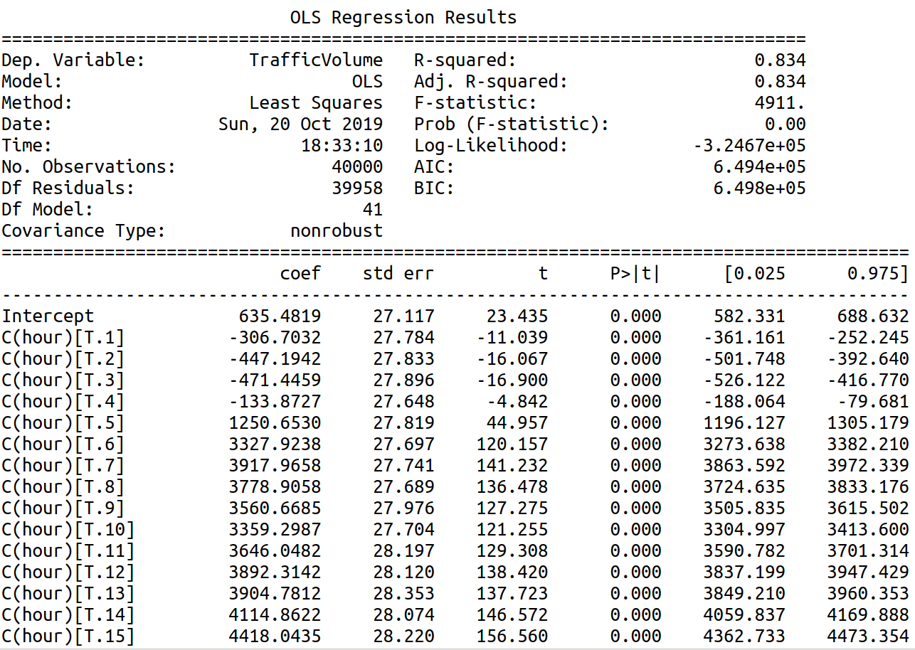
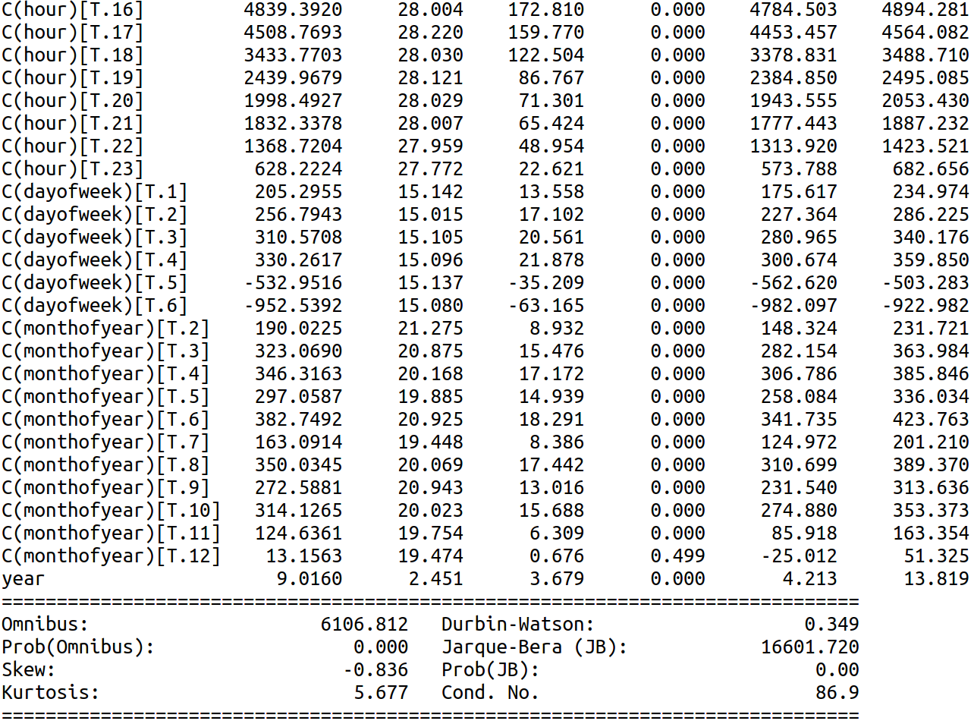
(‘hour', 'C(hour)', 'dayofweek', 'C(dayofweek)', 'dayofmonth', 'C(dayofmonth)', 'dayofyear', 'C(dayofyear)','C(weekofyear)', 'weekofyear', 'C(monthofyear)', 'monthofyear','year')
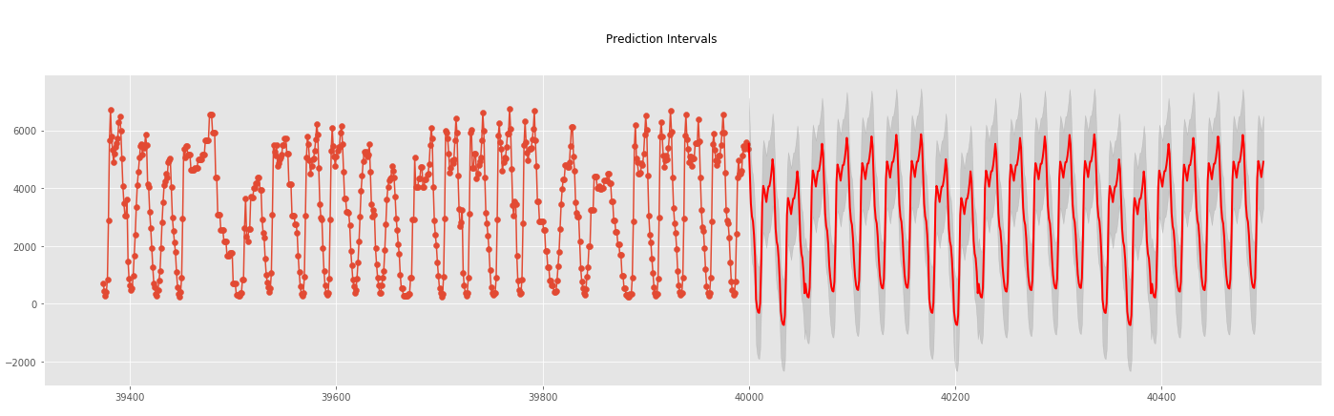
Both yielded slightly better results (1.1 point higher in R²-adjusted and 2000 lower in AIC) but have much complex models. For ease of interpretation, we will opt for the first regression model based on the AIC criteria.
Predicting future dates gives the right seasonal trend with however some values below 0.

2.1.2 Diagnostic check
-Residuals plot shows a non-normally distributed set of residuals especially for the lower quantiles with non-constant growing variance of the residuals when compared to the fitted values. Assumption of homoscedasticity may not be true.
-Moreover, when fitted values are negatives, residuals are always positive. This is because the prediction intervals should always have an inferior bound of 0.
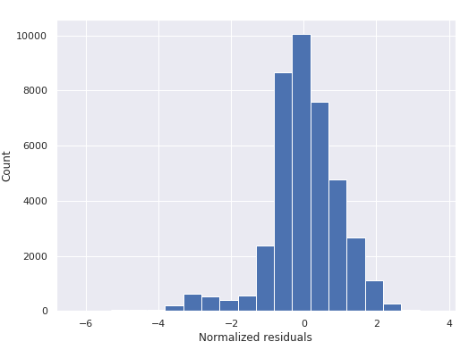
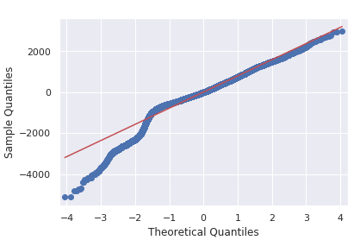
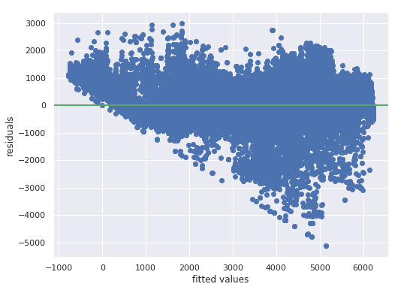

2.1.3 Model interpretation
The year is present in our model as a normal feature of linear regression. We have included 3 levels of seasonality : hour, day of the week, month of the year.
The base value is 635.48 at base hour, base day of week and base month.
- The base hour is hour 00:00. We observe that hours between 1:00 and 4:00 have negative coefficients in front of the related dummy variables and hours between 5:00 to 23:00 have positive coefficients with a culminating point at 16:00.
C(hour)[T.16] =4839.3920 can be interpreted as : the model predicts that under the exact same context and variables (ie same features) and only changing the hour from 00:00 to 16:00 would increase the Traffic Volume by 4839 units.
- The base day is dayofweek=0, ie monday. High traffic seems to be in working days with a maximum on dayofweek=4, ie Friday. We note that variation across days are less important than variation across hours
- The base month is month=1 ie January. All coefficients are positive meaning that January can be seen as the month with the lowest traffic. There are 2 peak periods : from March to June and from August to October.

2.2 Exponential Smoothing
We will then apply exponential smoothing to make forecasting.

2.2.1 Naive application of Exponential smoothing
We will apply a simple exponential smoothing based on the assumption that the observations follow a constant trend modal:
y_{t} = β₀ +ε_{t} with β₀ the constant term and ε_{t} the random residual term
We will calculate the optimal alpha given the SSE = Σ[Y_{i} - L_{i-1}]²
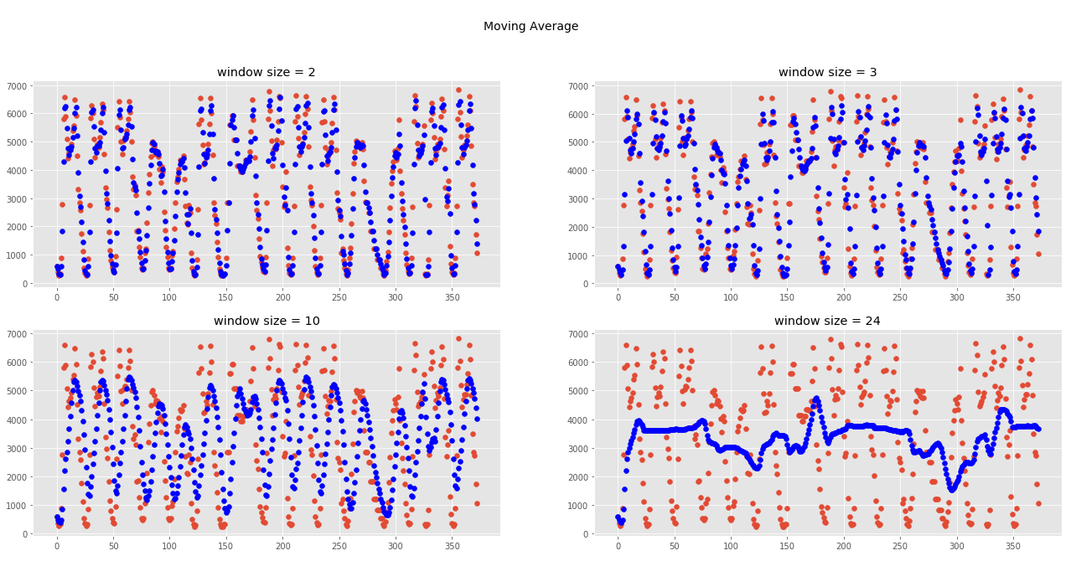
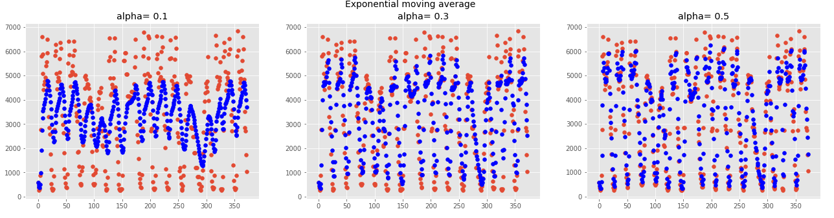
This resulted in an optimal alpha of 1.0 ie the optimal prediction of
Y_{n} is L_{n-1}= αY_{n-1}+(1-α) L_{n-2} =Y_{n-1}. The best estimation is the previous value. We may need to review our assumptions when using the exponential smoothing.

2.2.2 Verification of model choice, upsides and downsides
The exponential smoothing is based on constant parameters (ie TR_{t}, SN_{t,}) and constant variance over time.
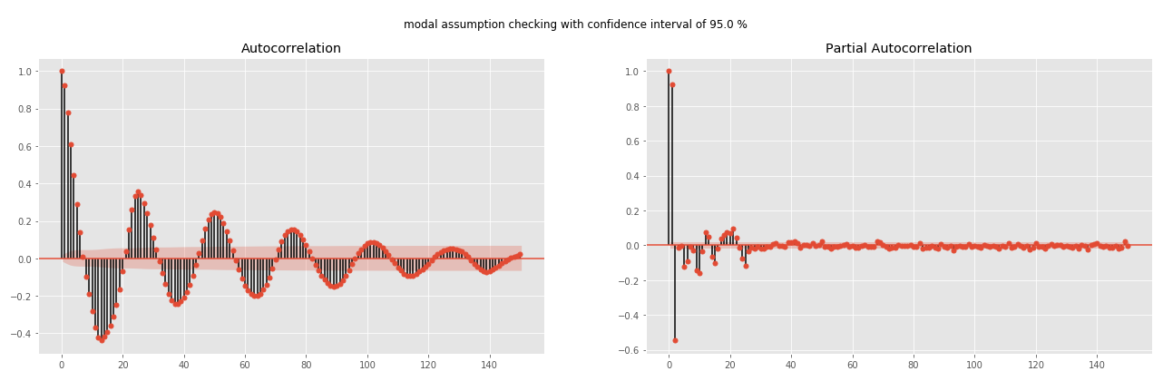
By plotting the autocorrelation plot, we do notice a sinusoidal autocorrelation function, which is a synonym for seasonality. As for the trend term, plotting the moving average by month and by year shows a relatively constant mean and thus can assume in first instance that the trend is constant

To account for the seasonal trend only, we can apply the Holt-Winters methods with a seasonal trend corrected smoothing and neglecting the linear trend term.

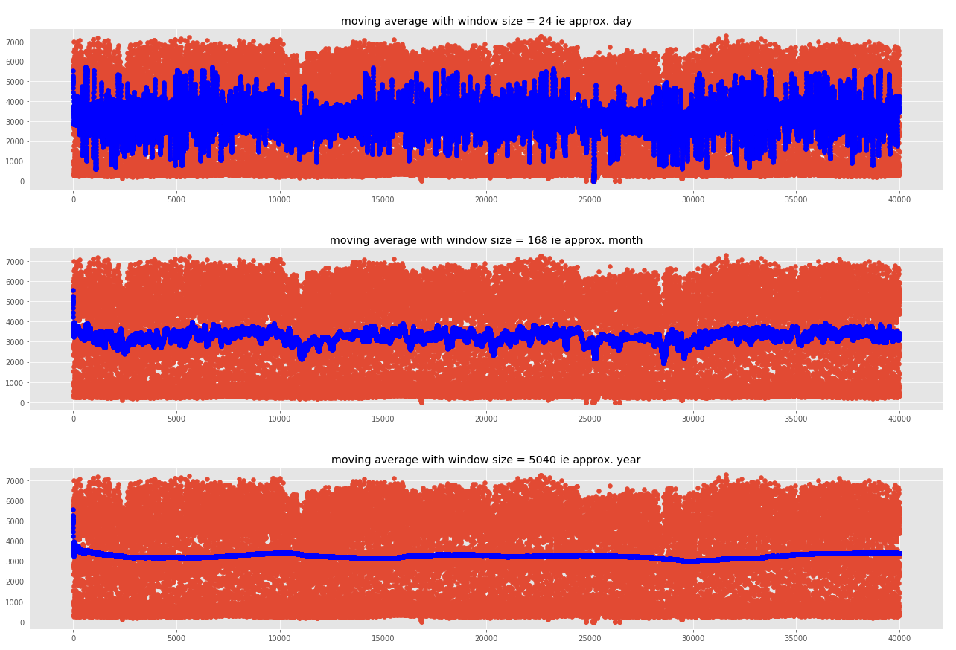
2.2.3 Holt-Winters exponential smoothing
- Since the hour variable is the most influential one, we can first develop a model with an hourly seasonal variation (L=24).
- Y_{t} = β₀ + β₁t + SN_{t} + ε_{t} with β₁t=0 meaning that Y_{t} = β₀ + SN_{t} + ε_{t}
with the following update:
L_{n} =α(Y_{n} − SN_{n−L} ) + (1 − α)(L_{n−1} )
SN_{n} =δ(Y_{n} − L_{n} ) + (1 − δ)SN_{n−L}
- Applying this methods would however require a uniformly sampled data with exactly one row per hour ie no duplicated or missing values for a unique hour/date which is not always the case here.

2.3 Free form forecasting
We will first apply a linear regression using features non related to time and dummy variables to model the seasonal variation and then apply an ARIMA modal (or Box-Jenkins methodologies) to modal the residuals of the previous forecast of traffic volumes.
Y_{t} = TR_{t} + SN_{t} + ε_{t}
with TR_{t}+SN_{t} ∼ Linear Regression and ε_{t} ∼ ARIMA(p, q)

2.3.1 Data cleaning
Following data cleaning (wrongly labeled/ outliers data) have been necessary to yields satisfactory results:
-‘IsHoliday’ is only flagged for the first hour of the day. We will flag it for all hours.
We do notice also some days that are wrongly labeled that would need further investigations (ex : 2017-01-02 labeled as ‘New Year’, maybe due to an error in time zone conversion)
- ‘Rain1h’/ ‘Temp’ with abnormally high/low values are put at nan and interpolated with neighboring values.

2.3.2 Linear regression
Among the different linear regression tested, the model with interaction effects included obtained by forward selection seems to be a good trade off between low testing errors and low model complexity.
Model and methods used | Train errors (MAE) | Test error (MAE)
1-full model | 586.59 | 589.46
2-model obtained by forward selection | 586.91 | 590.15
3-full model with interaction effect | 235.54 | 245.33
4-model with interaction included obtained by forward selection | 254.34 | 261.16

2.3.3 Linear regression with ARIMA errors
The residuals obtained have been used as entry for an ARIMA modeling. This methodology works best when data is stationary i.e. mean, variance and autocorrelation are constant over time.
Differencing ( z _{t} = y _{t} − y _{t−1} ) one time makes indeed the data more stationary (left) with a more constant average and standard deviation:
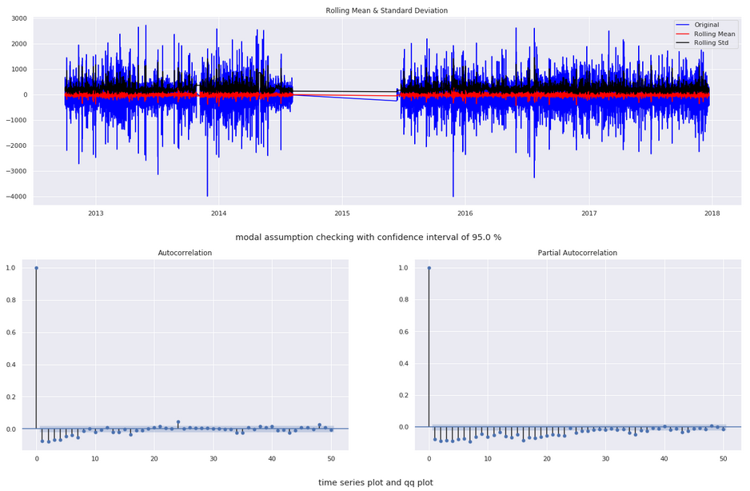
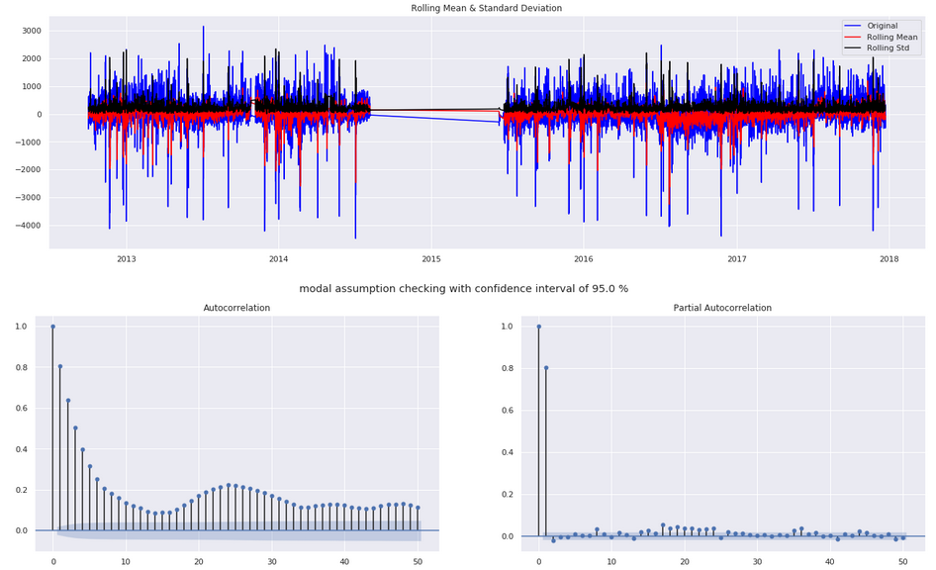
The ACP (of differenced residuals displayed below) however still reveals some seasonality effects. And lag 1 of partial autocorrelation is too negative and we might have over-differenced.
We will then try a gridsearch on both (not differenced and differenced) to look for the orders optimizing the cross validation errors.

ACP and PACP of differenced residuals :
For the AR term, by looking at the Partial autocorrelation plot, we notice that lag 1 is quite significant and lag 2 much less. We can tentatively look for values of p =0 to p=1.
For the MA term, by looking at the autocorrelation plot, we can tentatively look for values of q= 0 to q=5.
ACP and PACP of residuals
ACP and PACP of differenced residuals
(p,d,q)=(1,0,1) gave the best results among all the possible combinations when comparing mean absolute cross validation errors.
However the errors are small (<1%) when comparing errors of ARIMA (p,d,q)=(1,0,1) and (p,d,q)=(0,0,0) (model without ARIMA)
Those results needs to be however taken with a pinch of salt since ARIMA have been performed on a datasets that was not correcly sampled.

Due to time constraints and the quality of the data, I was able only to begin coding the residuals prediction with ARIMA. We would need in fact a clean, correctly sampled training and testing sets to correctly predict the right number of lags for forecasting purpose.
The first resampling step has been done and has yielded slightly better results for the linear regression model. We can explain this by assuming that some replicated rows now have less weights in the new model.

2.3.4 Further Improvements
- Further data quality improvements notably on value imputation and processing (Holidays for instance) and data resampling (define strategies to treat the nan that have appeared due to the resampling)
- We can also explore the different options of combining linear regression and ARIMA :
-ARIMA on the time series of TrafficVolume
-ARIMAX on the time series of TrafficVolume and features
-SARIMA on the time series of TrafficVolume
-SARIMAX on the time series of TrafficVolume and features
-multiple series modeling with TrafficVolume and Temparature

